ACCESS MANAGEMENT
About PUBLIC ROLE
Public role is a pseudo role that is automatically granted to every user and every role in your account. The PUBLIC role can own securable objects, just like any other role.
However, the objects owned by the role are by definition available to every other user and role in your account.
This role is typically used in cases where explicit access control is not needed and all users are viewed as equal with regard to their access rights.
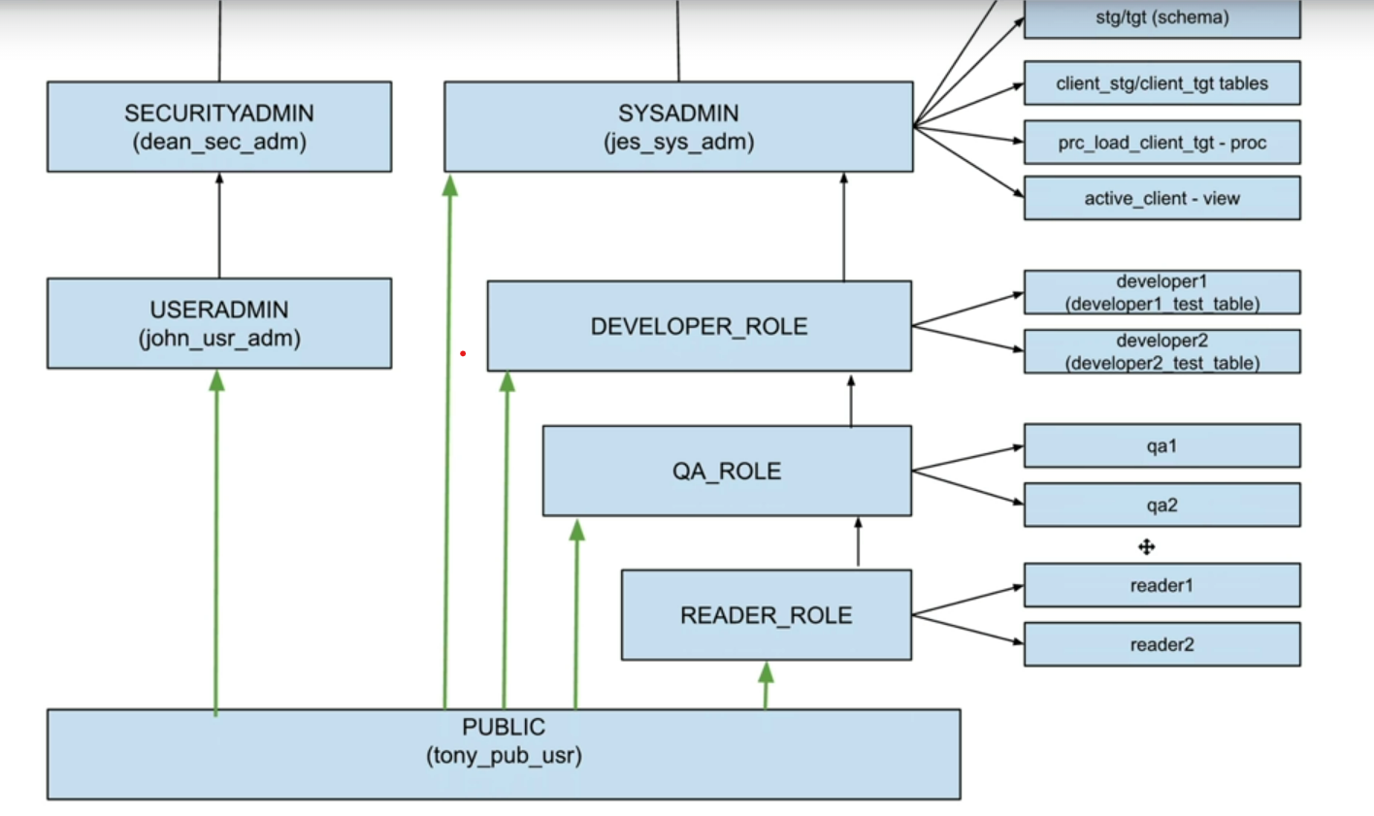
Let’s check by creating as per the above image

Creating a public user in user admin role
So, login to user admin role
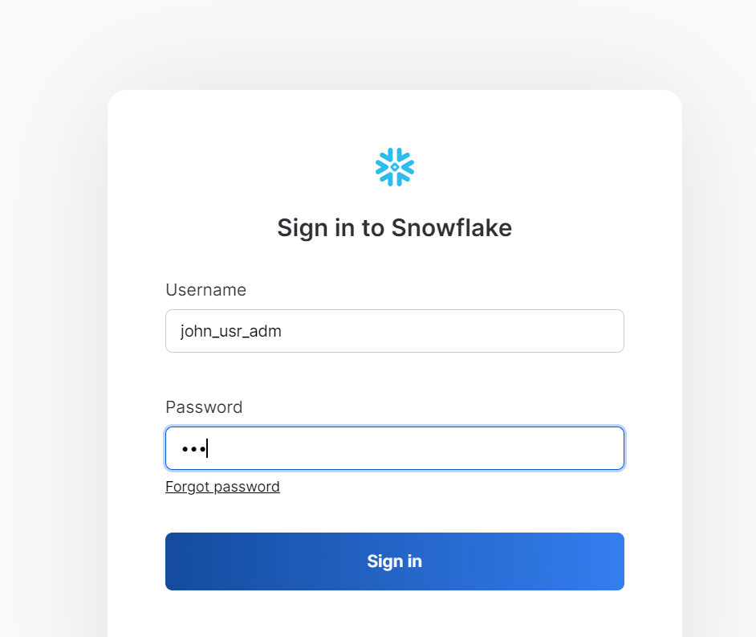
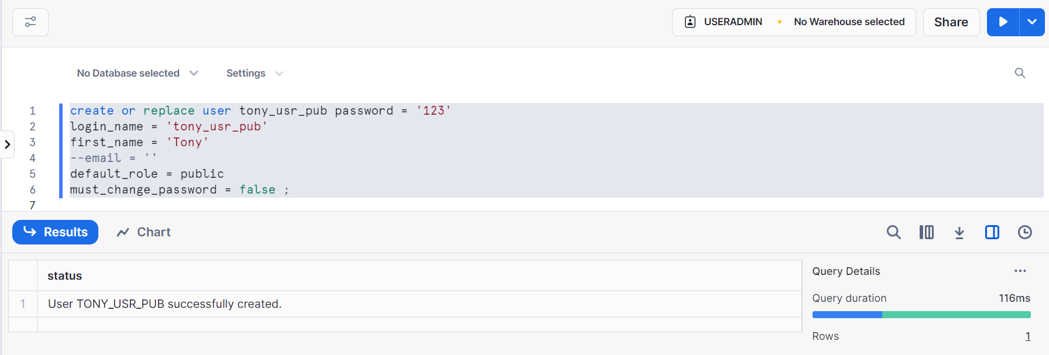

Let’s go to sysadmin and create some warehouses, databases and schemas and give privileges to public
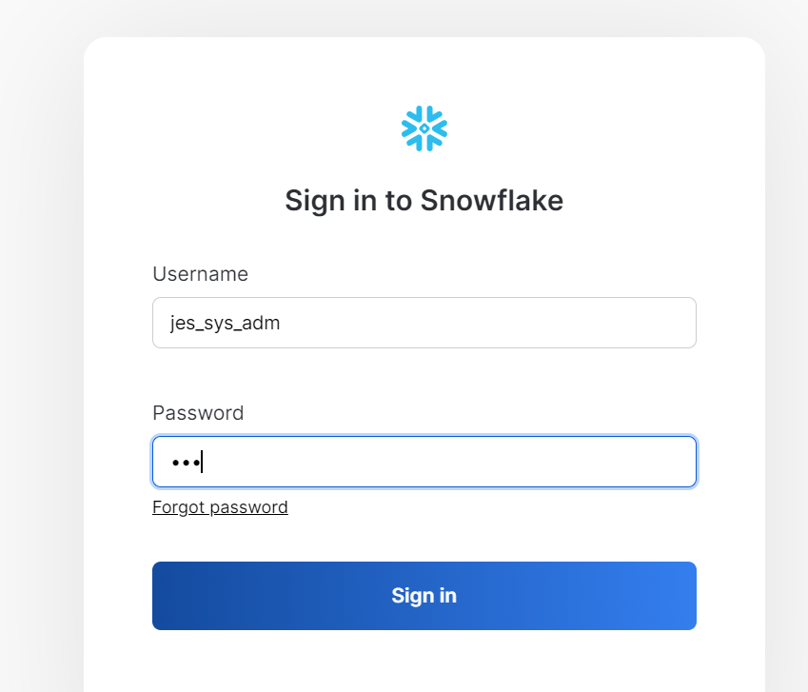
Creating a warehouse, database and schema
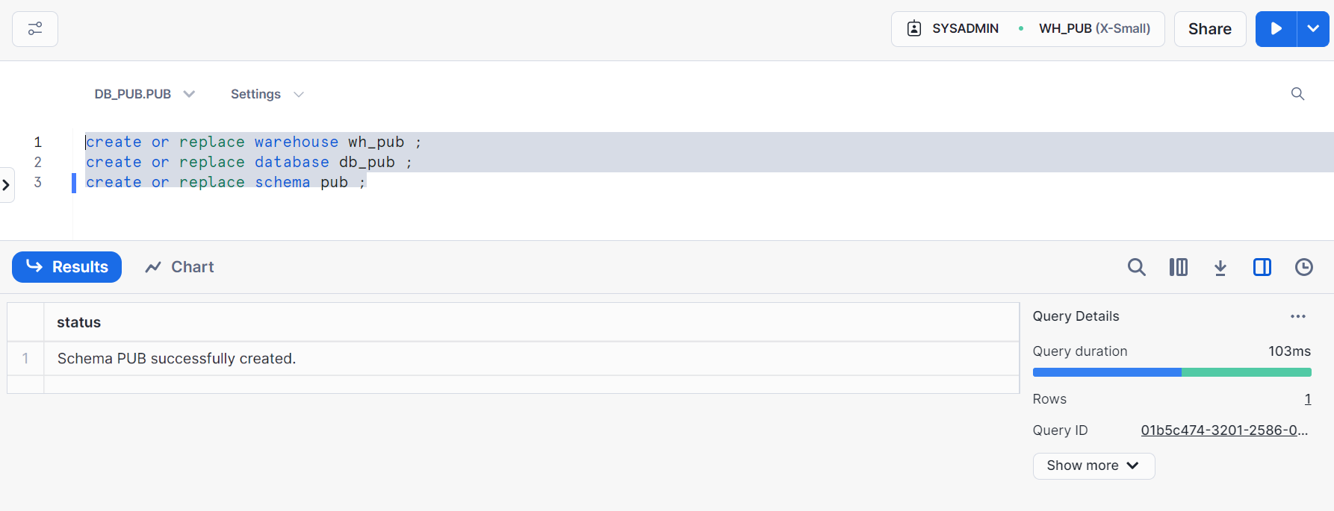

Let’s now give grant on usage wh_pub, db_pub, pub to public
This implies it (WH, dB, schema) will be available to every user and every role in the account
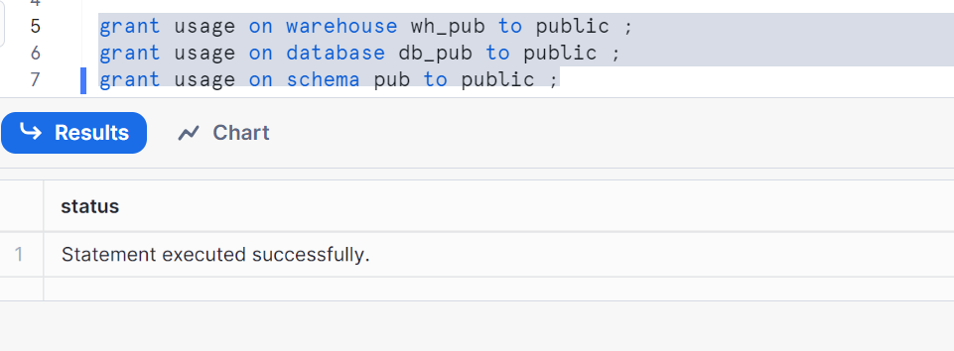
Now, let’s give all the access on the database and schema to public role
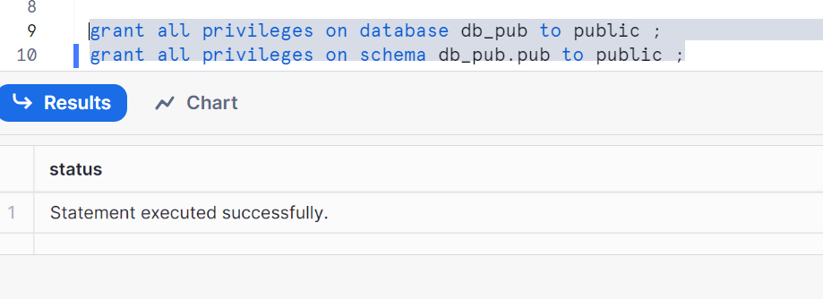
Now, let’s go back and see whether this particular warehouse, database & schema are available to our Tony user public role
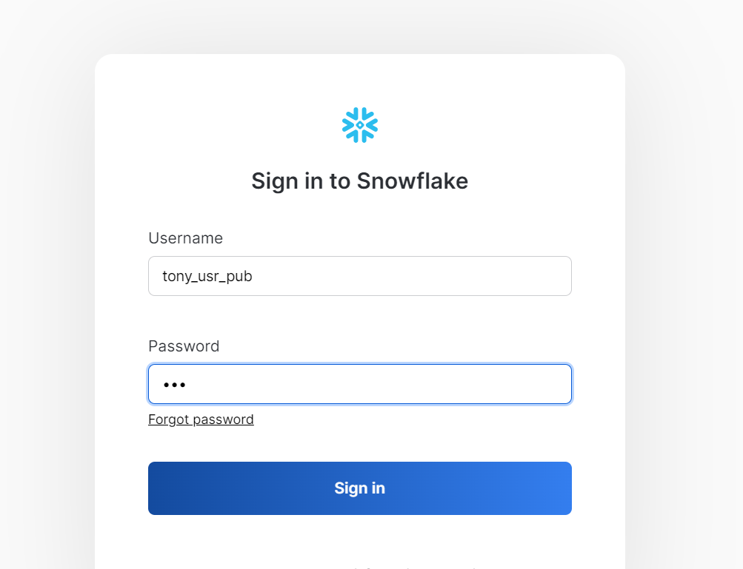
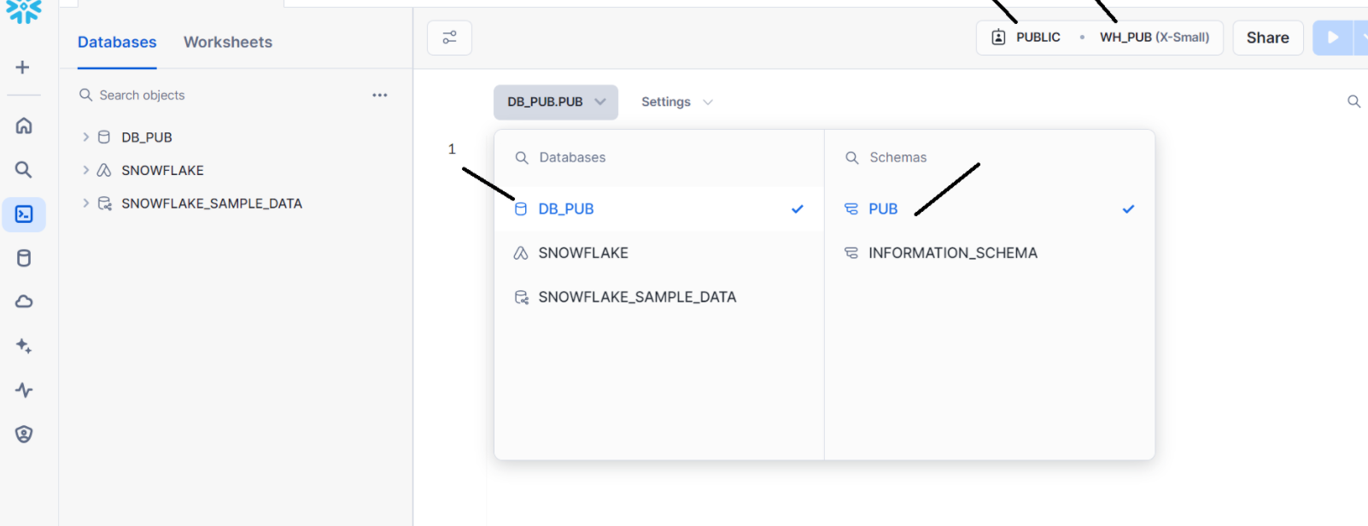
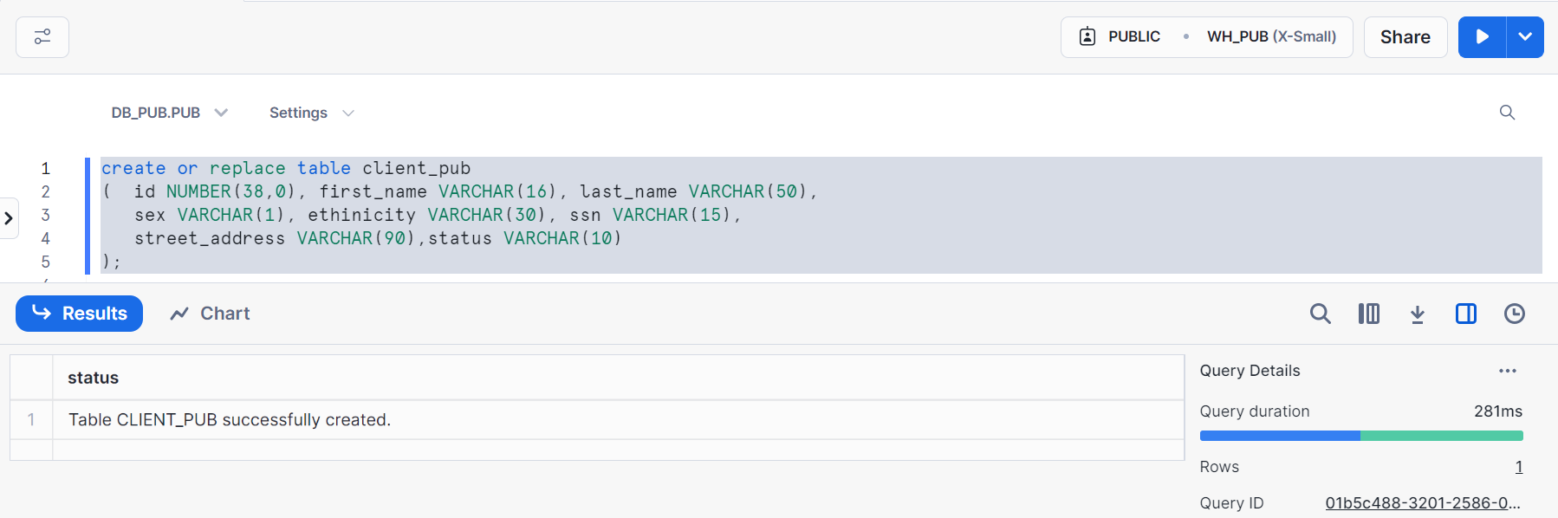
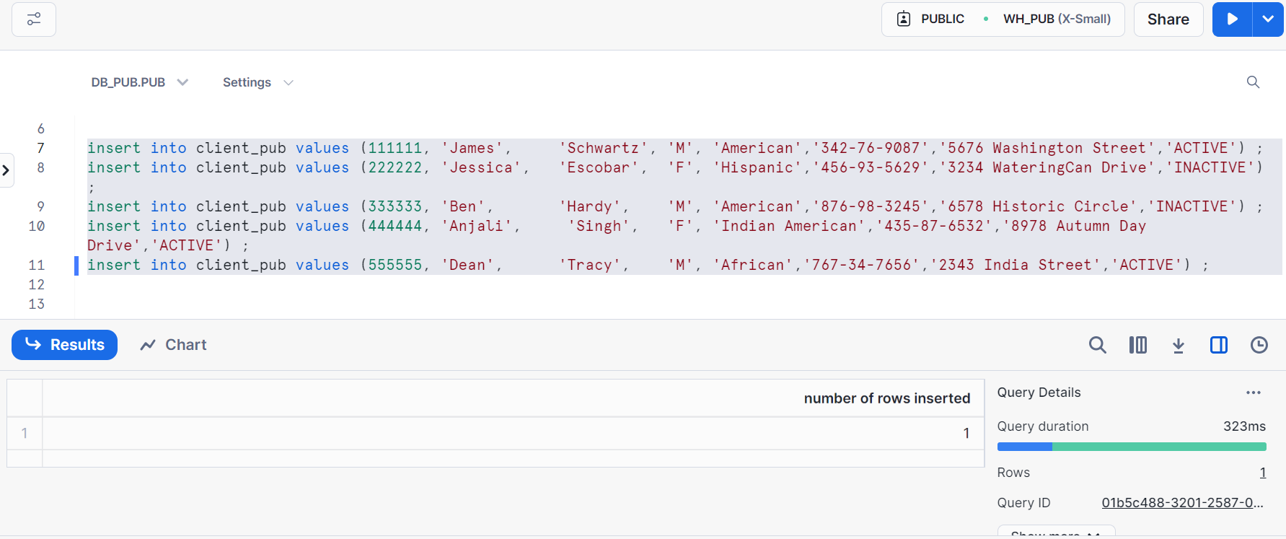
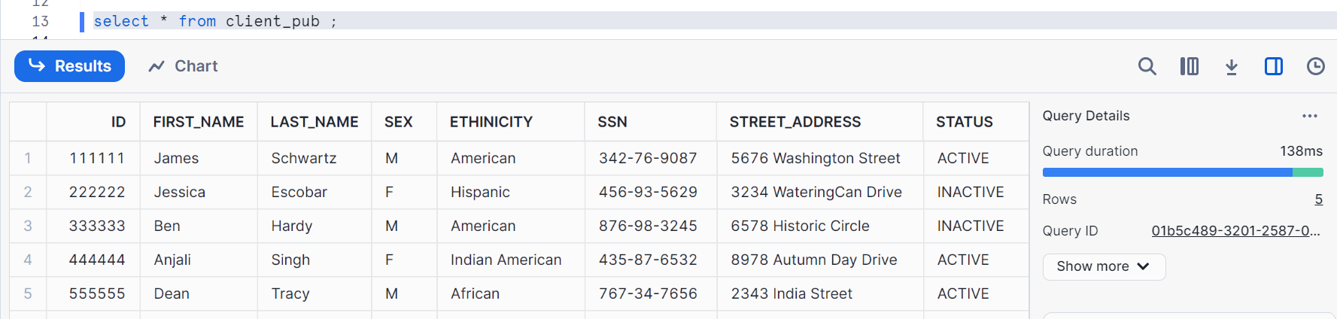

Now, let’s validate 4 things like this table (client_pub), schema (pub), database (DB_PUB), warehouse (WH_PUB) should be available across all the users and roles in our system.
Note: We have not given any explicit grant to any role or user. It is only to public
Let’s login to reader1 user
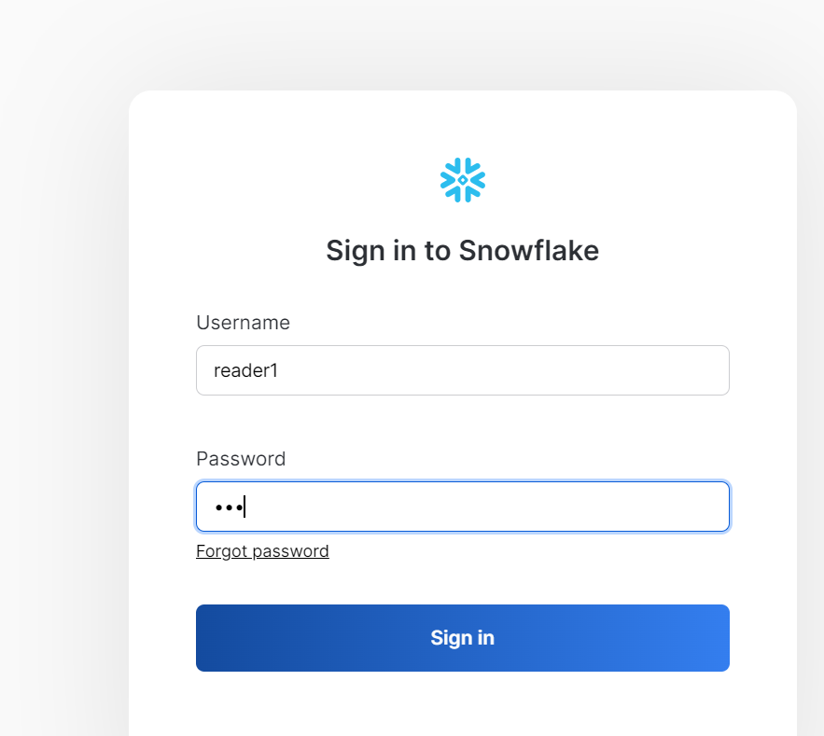
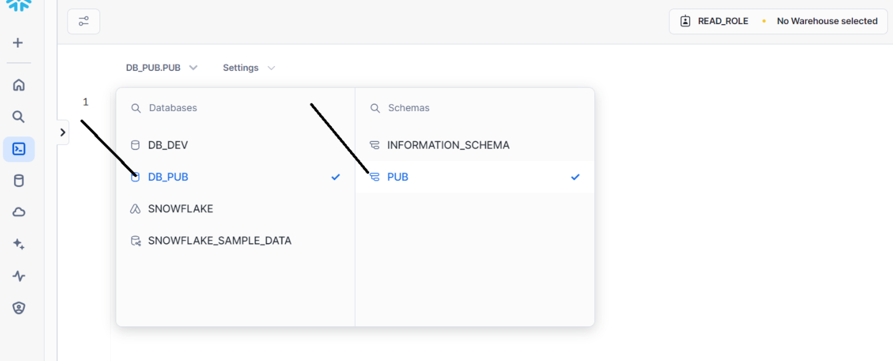
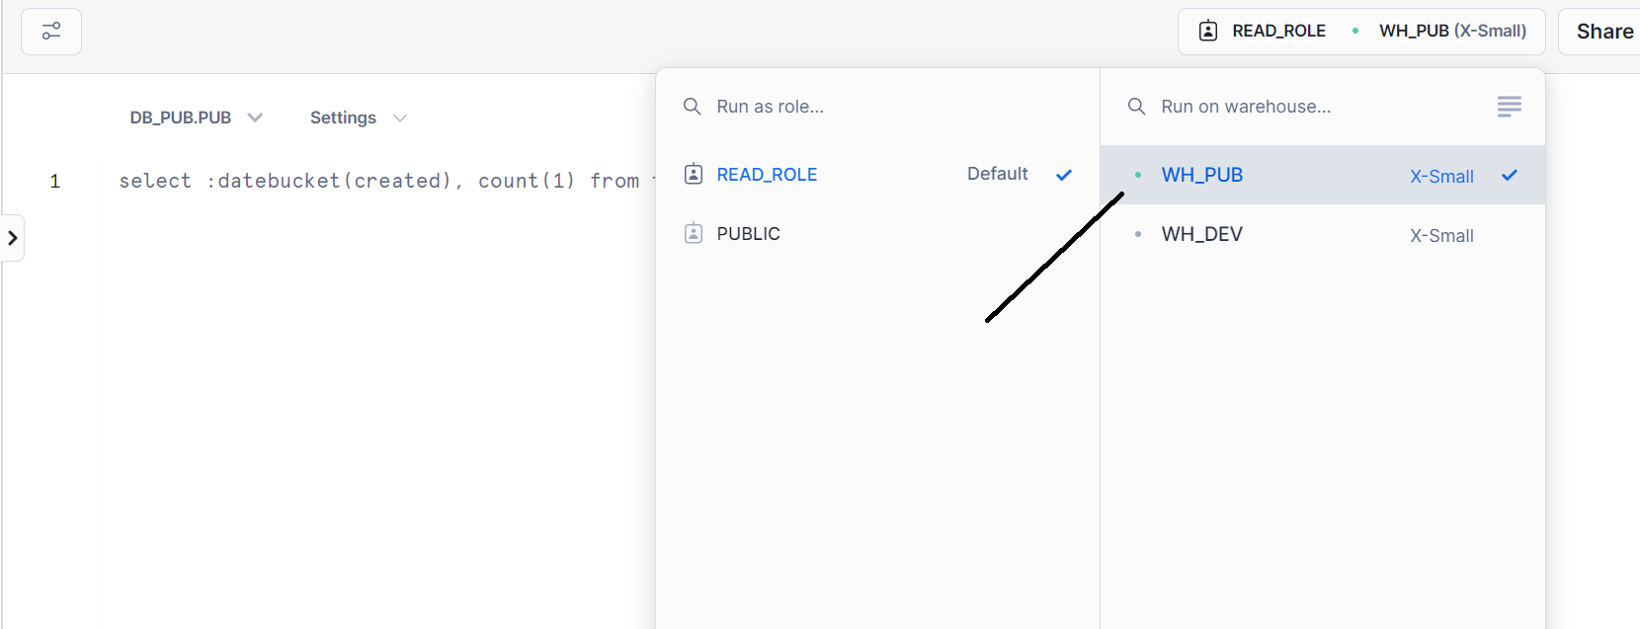
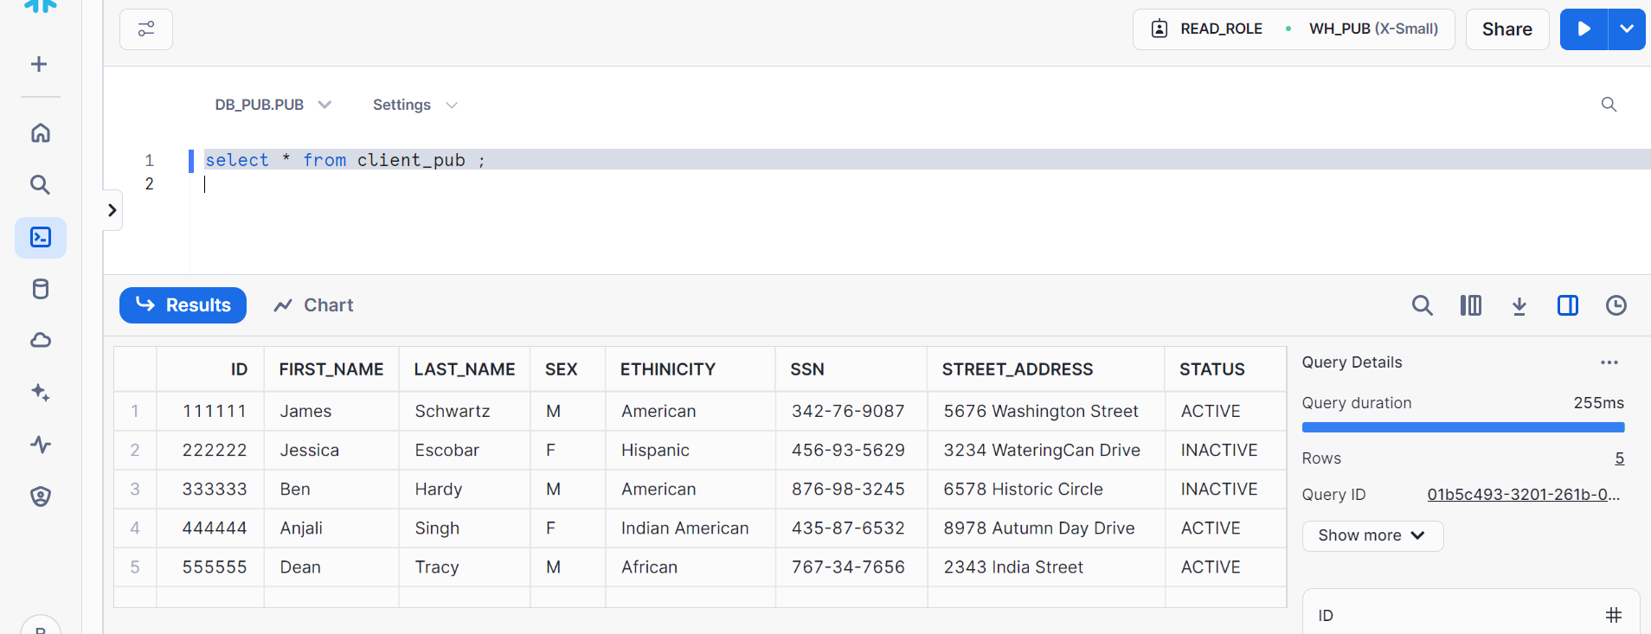

Now, since this particular table is inherited from public role to read role, so read_role can be able to delete this as below
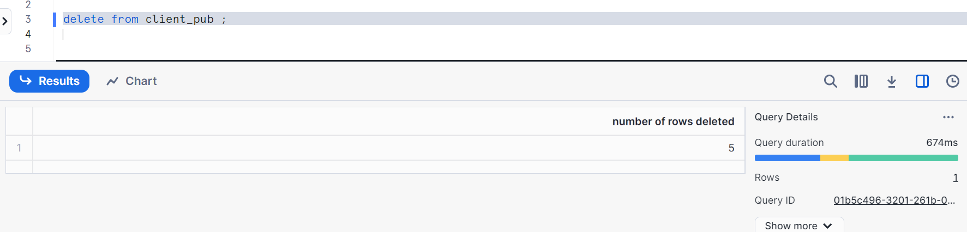
Even it can insert as well
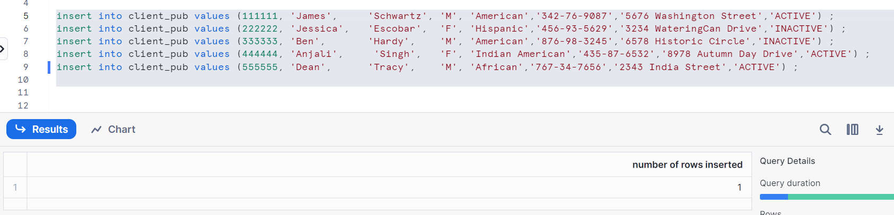
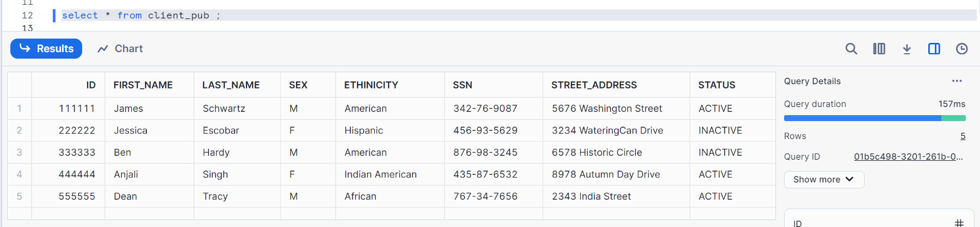
Even it can update as well
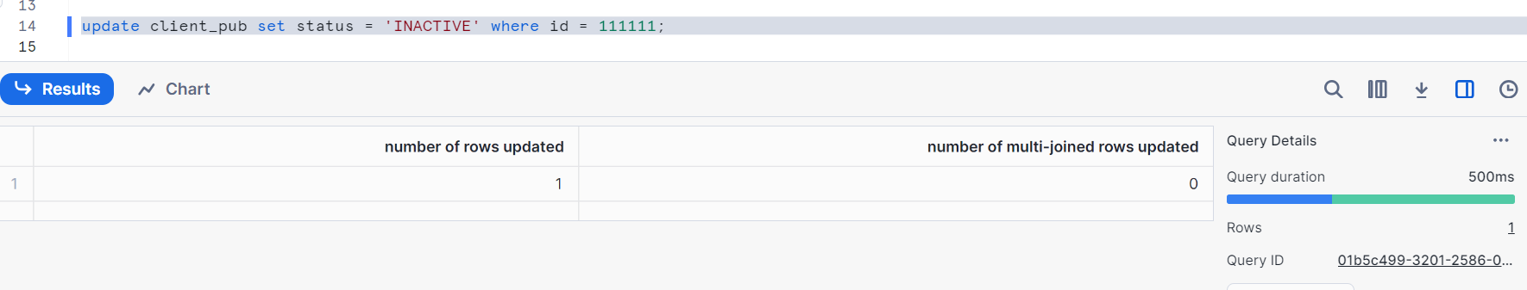

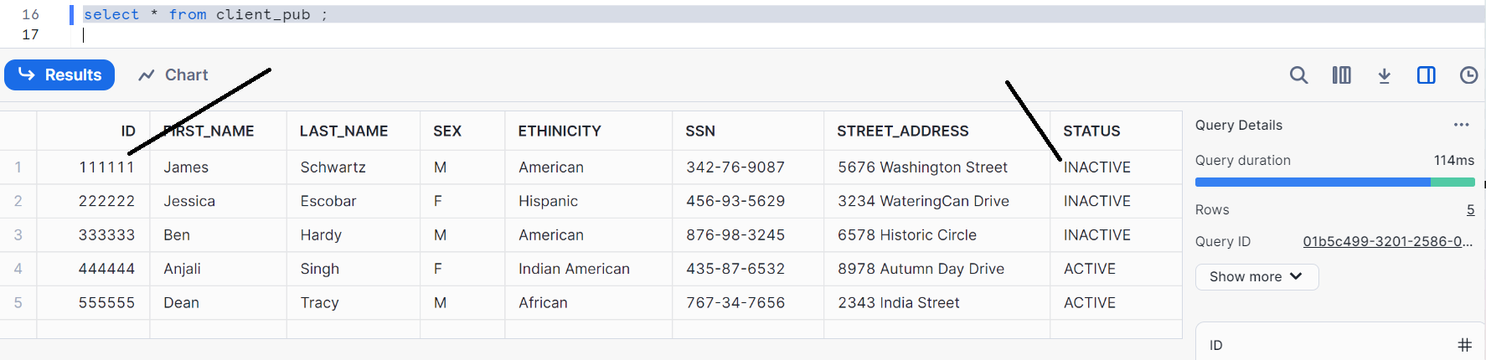
Let’s login to security admin role and check
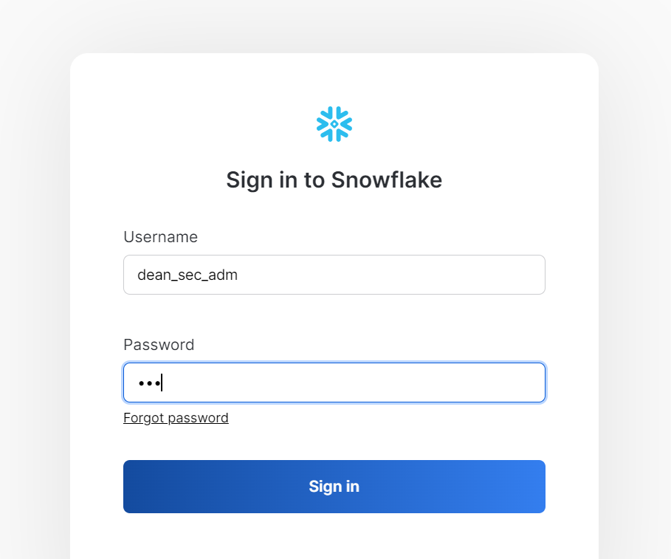
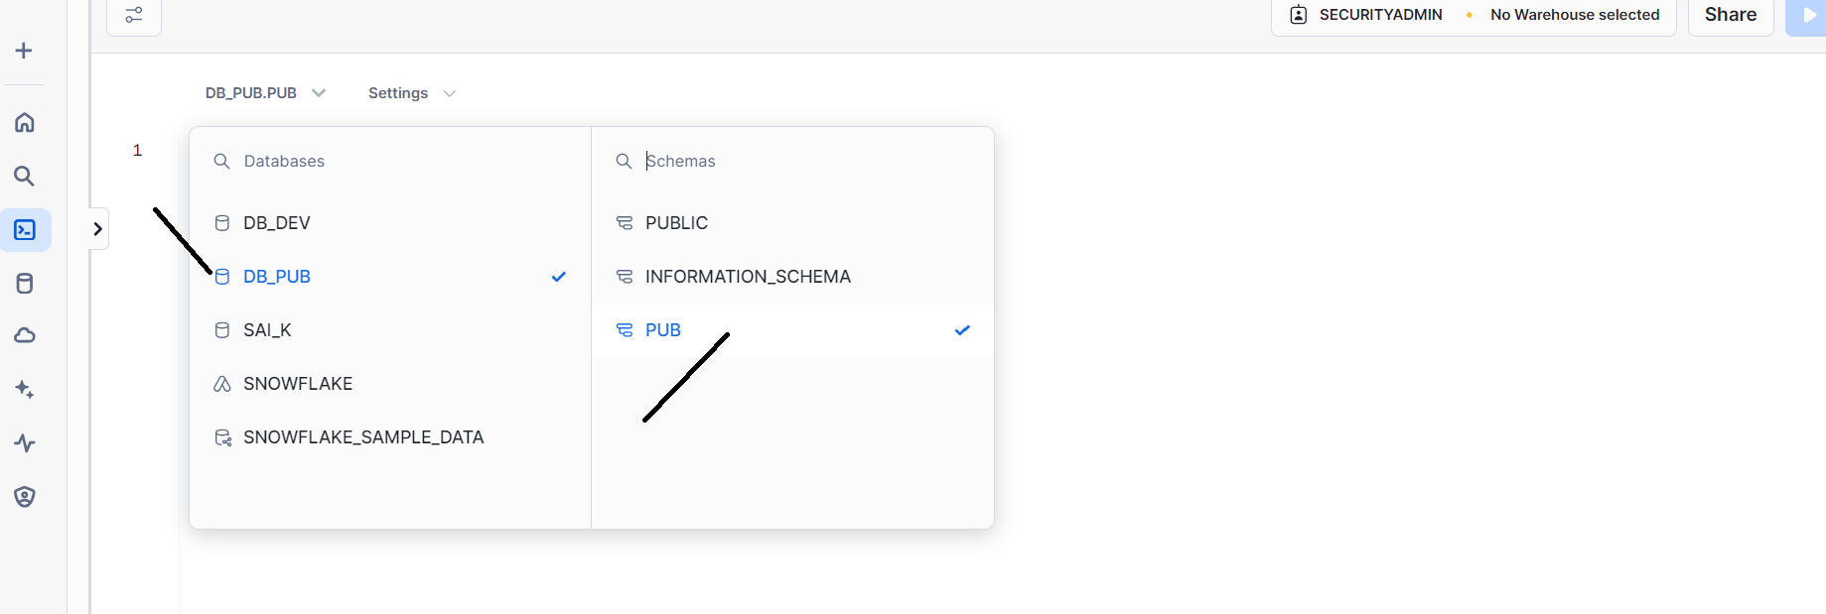
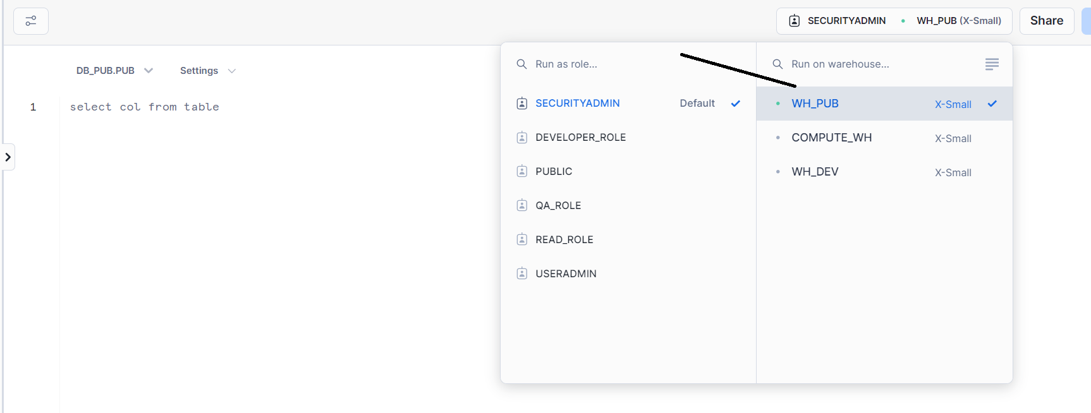
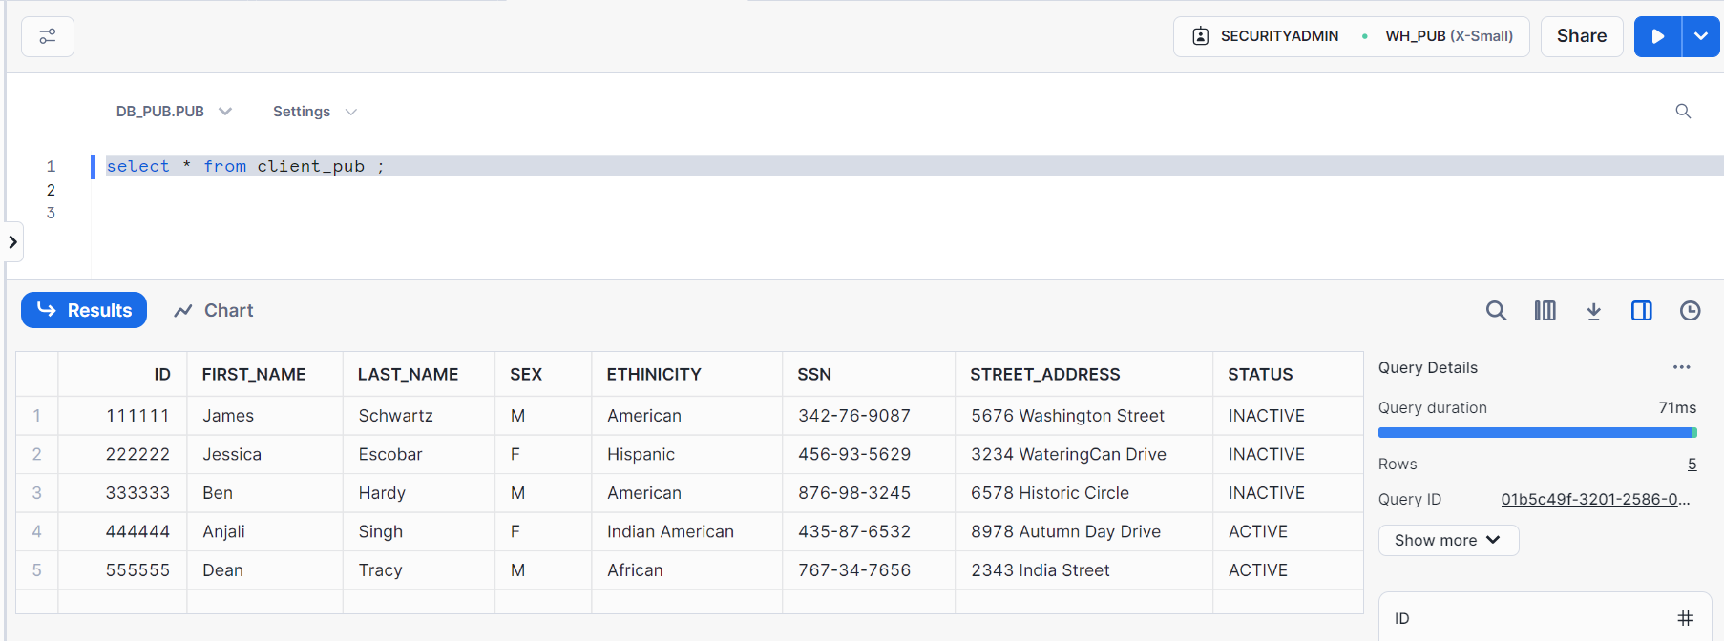
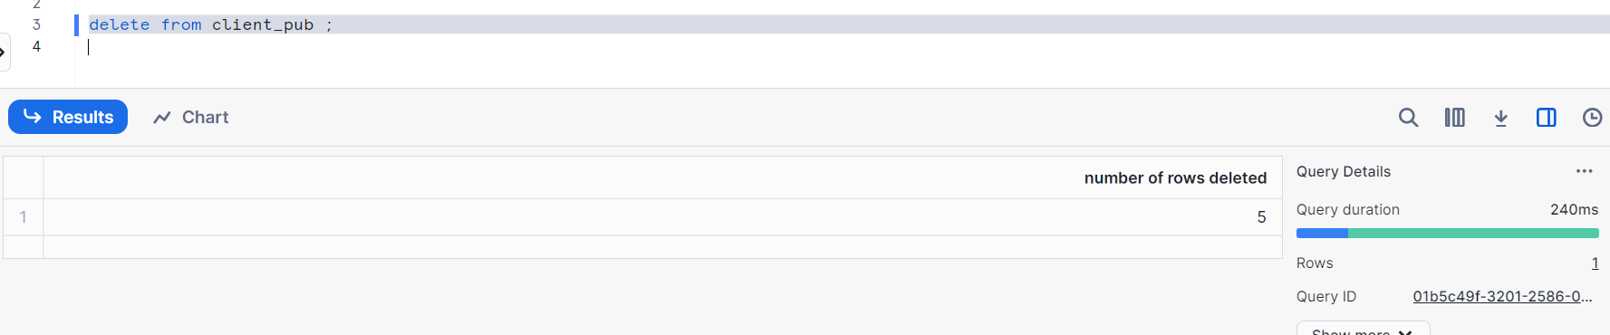
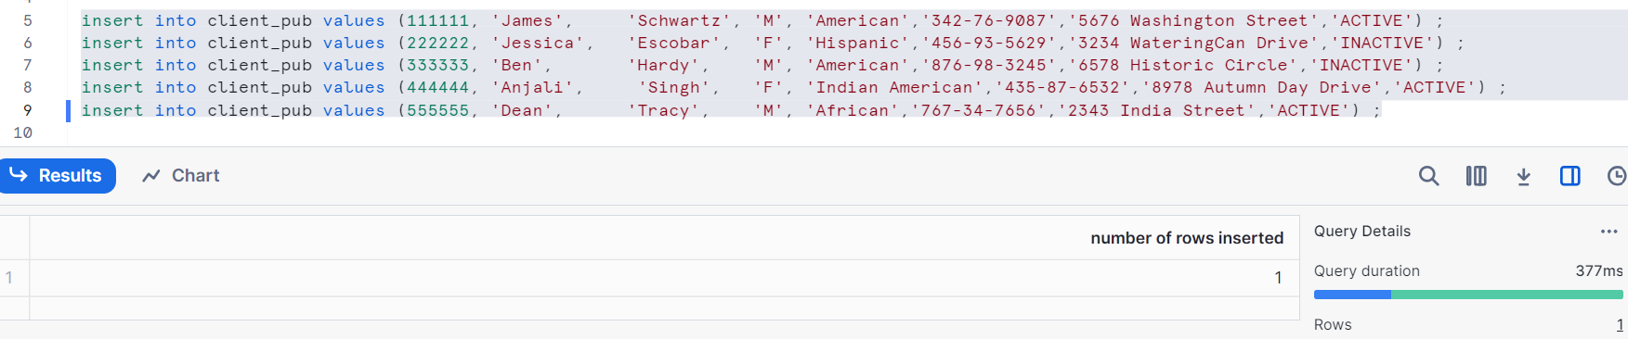
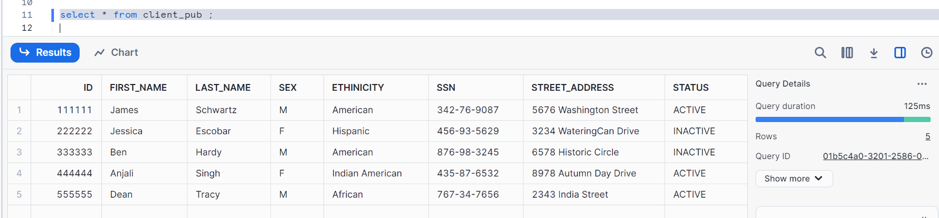
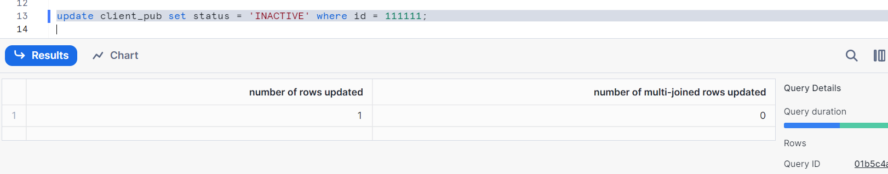
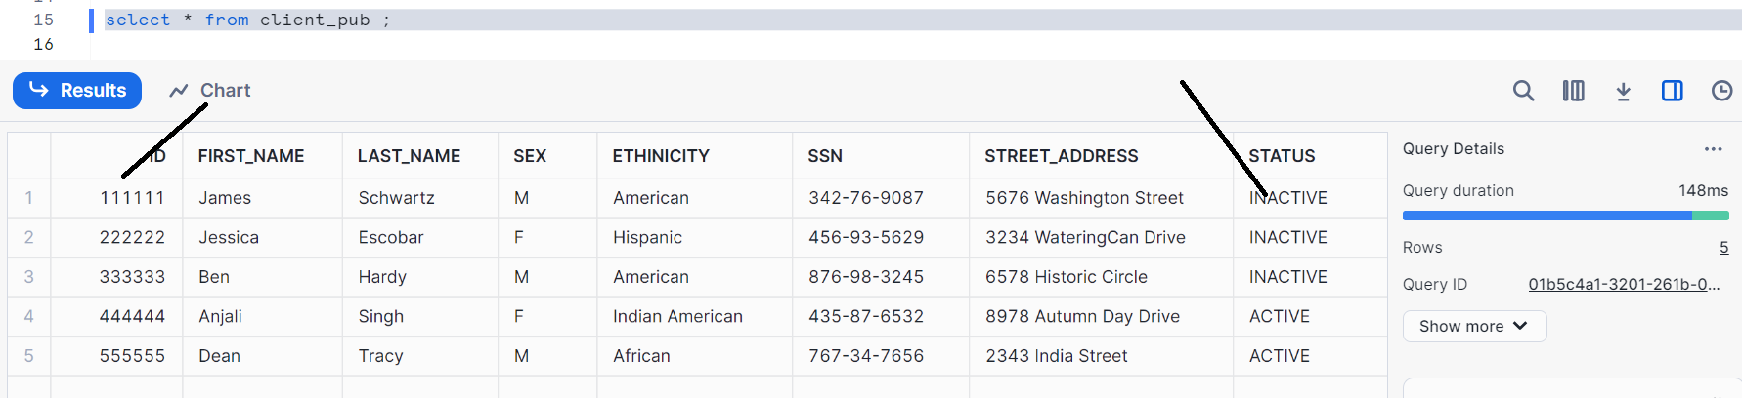
Everything works well in security admin

Let’s check in account admin role
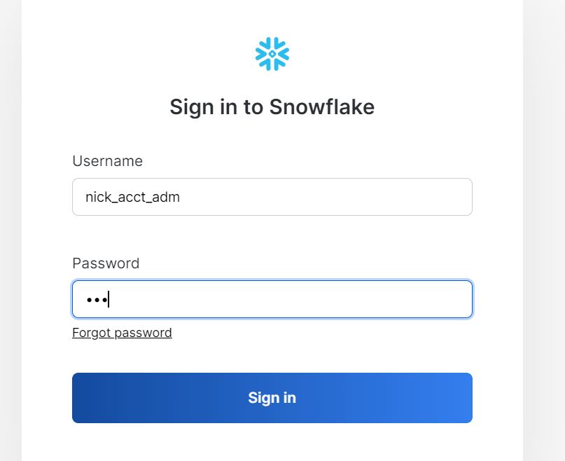
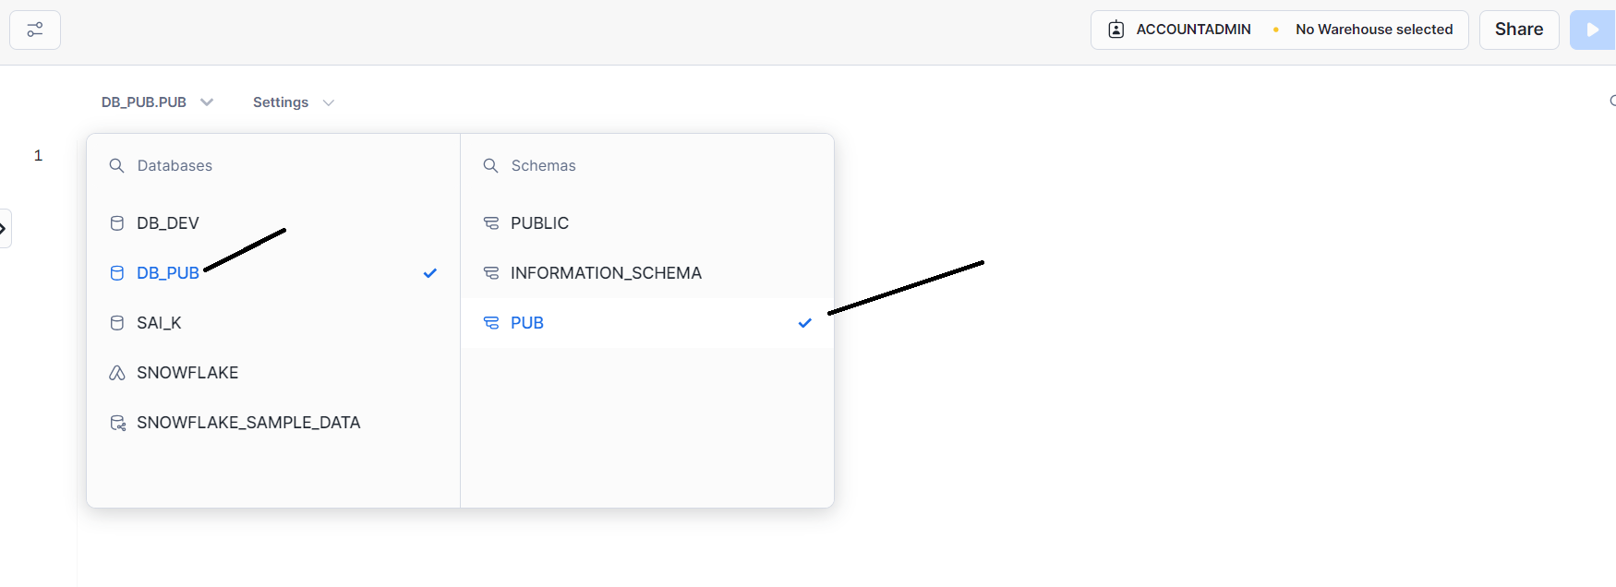
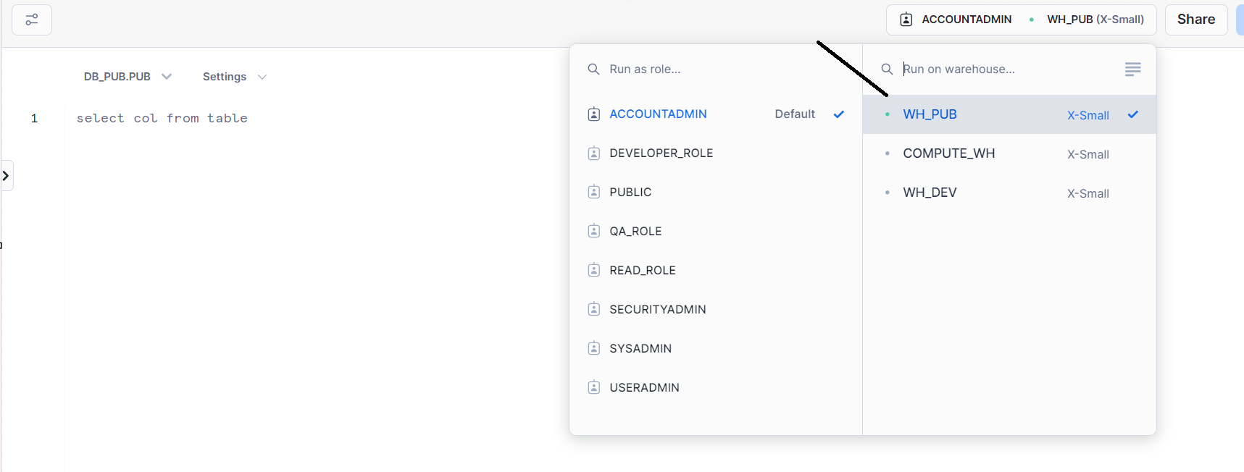
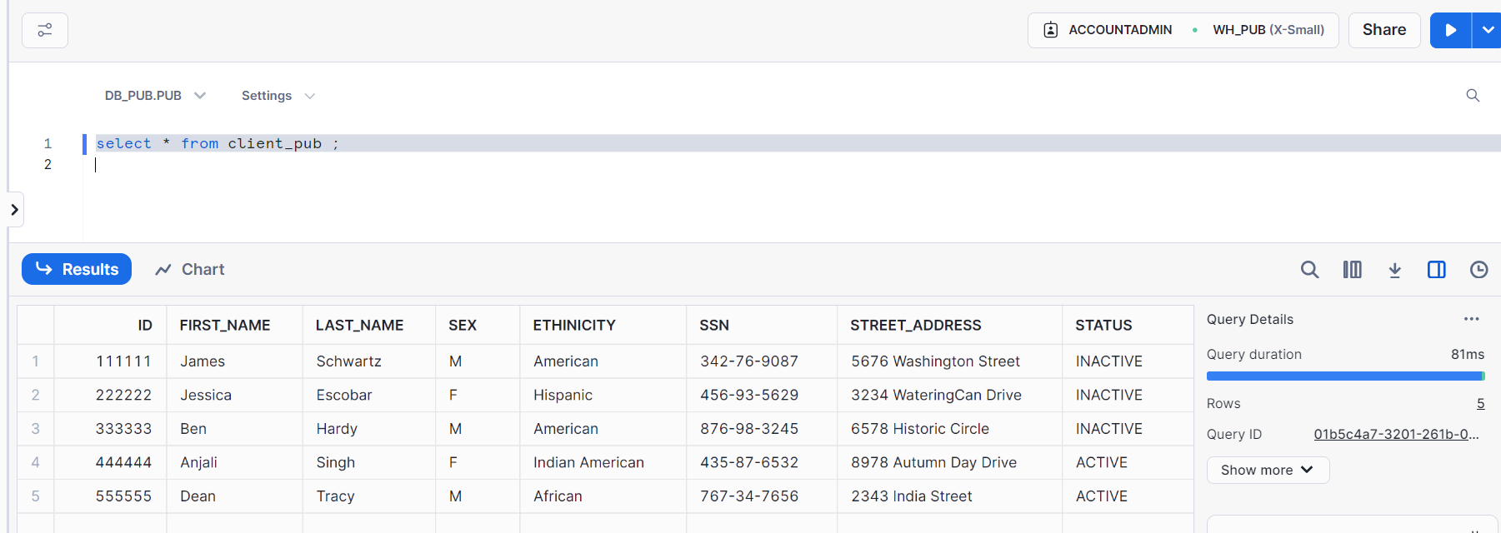
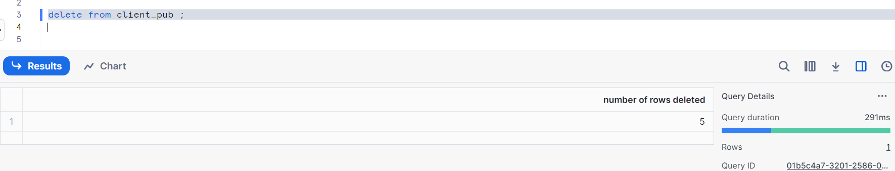
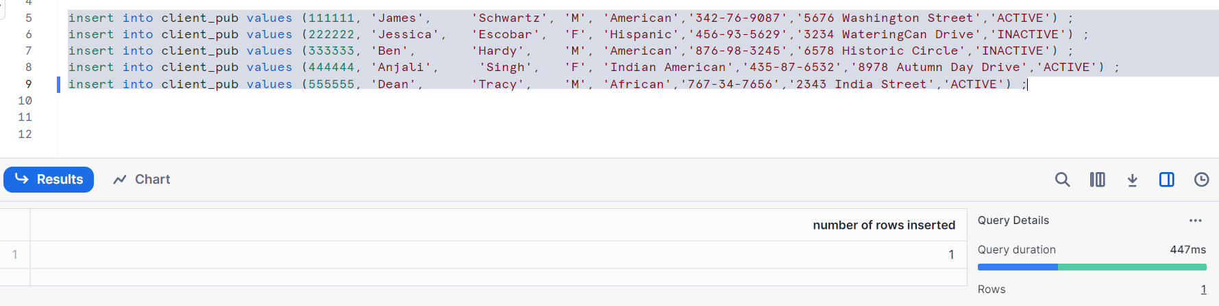
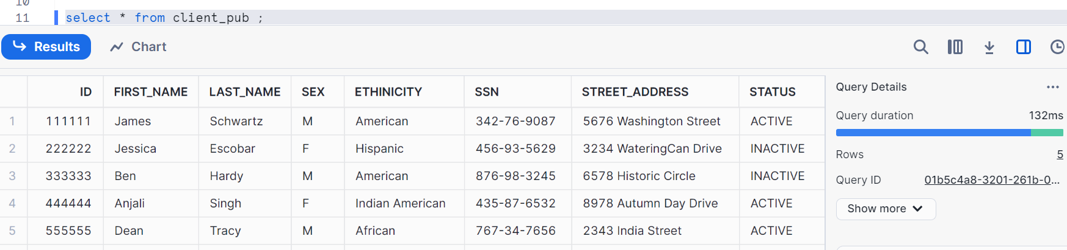
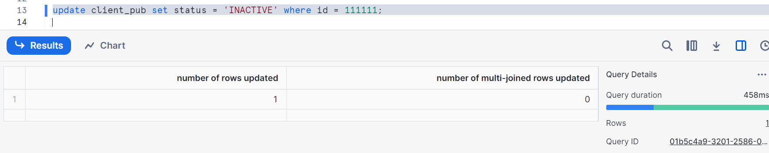
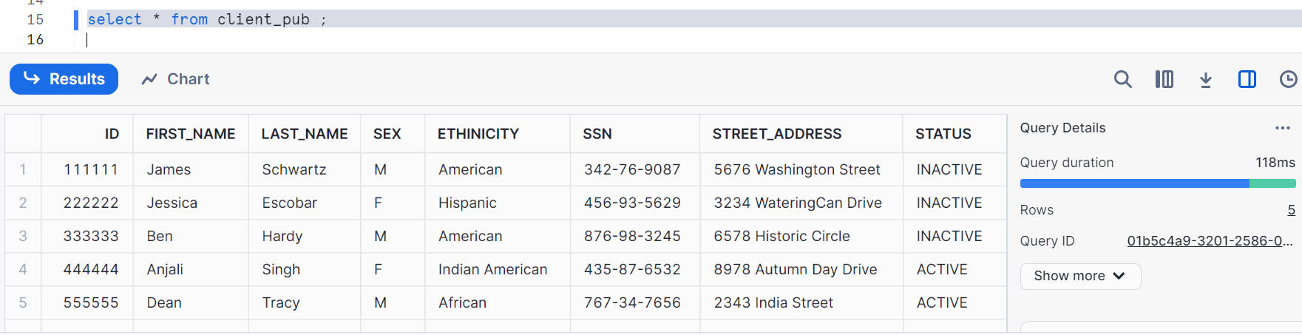
Everything works well in account admin role as well

Thanks,
With this access management topic is done
A few topics are left which will be done in next 3-4 posts and 90% of snowflake will be done

